Project Title: The Smart Crime Analytics Portal (SCAP)

Group Details:
Student Number | Name of the Student | SAP ID | Class | Division
1 | Jhanvi Rai | 53013240076 | TYBScIT | B
2 | Jiya Thakur | 53013240136 | TYBScIT | B
3 | Hitanshi Shah | 53013240065 | TYBScIT | B
4 | Hetvi Gajera | 53003230102 | TYBScIT | B

https://github.com/Jhanviraiii/Enterprise-Java1/tree/main
- Introduction

The Smart Crime Analytics Portal is a web-based application designed to improve the efficiency of crime management and criminal investigations by combining traditional crime record management with analytical capabilities. The system provides a centralized platform for law enforcement agencies to register crimes, manage investigations, store criminal records, upload digital evidence, and generate crime analytics.
Unlike traditional crime management systems that only store records, this portal analyses crime data to identify crime trends, detect similar crime patterns, highlight crime-prone locations, and generate analytical reports. These insights assist investigators in making informed decisions and improve the overall investigation process.
The portal will be developed using Spring Boot as the backend framework, MySQL as the database, and HTML, CSS, Bootstrap, and JavaScript for the frontend. The application will provide secure role-based access for Administrators, Police Officers, Investigators, and Forensic Officers.

1.1 Background
Crime investigation has become increasingly challenging due to the growing volume of criminal activities, digital evidence, and interconnected cases. Police departments and law enforcement agencies handle thousands of crime records, FIRs, criminal profiles, and investigation reports every year. Managing this information manually or using conventional record management systems often results in delayed investigations, duplicate records, and difficulty in identifying relationships between cases.
Traditional crime management systems primarily function as storage systems where crime information is recorded but not analyzed. Investigators often need to manually compare different cases to identify common suspects, similar crime methods, or repeated offences. This manual process consumes valuable time and may result in important connections being overlooked.
Another major challenge is identifying crime trends and hotspot locations. Without analytical tools, law enforcement agencies cannot effectively allocate resources or implement preventive measures based on crime statistics. Digital evidence such as CCTV footage, photographs, videos, and forensic reports also requires secure storage and integrity verification to maintain its authenticity during investigations.
The Smart Crime Analytics Portal addresses these challenges by integrating crime record management with analytical features. The system provides centralized storage, intelligent search, crime trend analysis, investigation tracking, and secure evidence management. It enables investigators to detect related crimes, identify crime hotspots, monitor investigation progress, and generate comprehensive reports for decision-making.

1.2 Objectives
The primary objectives of the Smart Crime Analytics Portal are:
- To provide a centralized platform for managing crime records.
- To automate FIR registration and investigation tracking.
- To maintain detailed criminal profiles.
- To securely store and manage digital evidence.
- To identify crime trends through analytical dashboards.
- To detect similar crime patterns and assist investigators.
- To generate statistical and administrative reports.
- To improve investigation efficiency through centralized information management.
- To provide secure role-based access to authorized users.
- To reduce manual paperwork and improve data accuracy.

2. Requirements Gathering
Requirement gathering involves identifying the functional and non-functional needs of the proposed system through discussions with potential users such as police officers, investigators, and administrators. The gathered requirements help define the features and performance expectations of the application.

2.1 Functional Requirements
FR1: User Authentication and Authorization
The system shall provide a secure login mechanism for all authorized users using a unique username and password. The system shall authenticate users before granting access to any module. It shall implement Role-Based Access Control (RBAC), where different users such as Administrator, Police Officer, Investigator, and Forensic Officer have different permissions. Passwords shall be securely stored in encrypted form, and users shall be able to log out securely.

FR2: User Management
The Administrator shall be able to create, update, delete, and manage user accounts. The Administrator shall assign roles and permissions to each user according to their responsibilities. The system shall maintain user profiles and record all login and activity logs for security and auditing purposes.

FR3: FIR Management
The system shall allow police officers to register new First Information Reports (FIRs). Each FIR shall be assigned a unique FIR number automatically. Users shall be able to update FIR details, search FIRs using different filters, and track the current status of each FIR. The system shall also maintain the complete history of changes made to every FIR.

FR4: Crime Record Management
The system shall allow authorized users to create, modify, delete, and search crime records. Each crime record shall contain information such as crime type, location, date and time of occurrence, description, assigned investigator, and case status. The system shall support searching records based on multiple criteria and allow investigators to update case progress throughout the investigation.

FR5: Criminal Profile Management
The system shall maintain detailed criminal profiles containing personal information, aliases, photographs, previous criminal history, known associates, and ongoing investigations. Investigators shall be able to associate one criminal with multiple crime records, allowing quick identification of repeat offenders and easier access to criminal history.

FR6: Evidence Management
The system shall provide facilities for uploading and managing digital evidence, including photographs, videos, CCTV footage, forensic reports, and documents. Every evidence file shall be linked to the corresponding crime record. The system shall generate a SHA-256 hash for each uploaded file to ensure evidence integrity and detect any unauthorized modifications. A complete audit trail of evidence access and updates shall also be maintained.

FR7: Crime Analytics Dashboard (Unique Feature)
The system shall analyze crime data stored in the database and generate dashboards containing statistical reports, graphs, and charts. Users shall be able to view crime trends based on crime type, location, time period, and investigation status. The dashboard shall also identify crime hotspot areas to assist law enforcement agencies in planning preventive measures and allocating resources effectively.

FR8: Crime Pattern Detection (Unique Feature)
The system shall automatically compare crime records based on various parameters such as crime location, modus operandi, suspect information, vehicle numbers, phone numbers, and crime timing. If similarities are detected between multiple cases, the system shall notify investigators about possible connections. This feature assists investigators in identifying serial offences and related criminal activities more efficiently.

FR9: Investigation Management
The system shall allow investigators to manage the complete investigation process. Investigators shall be able to assign cases, record investigation notes, update investigation progress, add suspects, upload additional evidence, and change the case status from Open to Under Investigation, Solved, or Closed. The system shall maintain a chronological investigation timeline for every case.

FR10: Report Generation
The system shall generate various reports, including crime reports, FIR reports, criminal history reports, investigation summaries, and crime analytics reports. Users shall be able to filter reports based on date, crime type, location, or investigation status. Reports shall be available for viewing on the portal and can be exported in PDF format for official use.

2.2 Non-functional Requirements
NFR1: Security
The system shall ensure that only authorized users can access the application through secure authentication. Passwords shall be stored in encrypted form, and role-based access control shall restrict users from accessing unauthorized modules. The system shall maintain audit logs of important user activities to ensure accountability and improve system security.

NFR2: Performance
The system shall provide fast response times for all operations such as login, crime record search, report generation, and data retrieval. It shall be capable of handling multiple users simultaneously without significant performance degradation. Search queries and analytics should execute efficiently to support quick decision-making.

NFR3: Reliability
The system shall ensure accurate and consistent storage of crime records without data loss. It shall maintain data integrity even during unexpected failures. Database backup and recovery mechanisms shall be implemented to restore information in case of system failure or accidental data deletion.

NFR4: Availability
The system shall be available to authorized users whenever required, with minimal downtime for maintenance. It should provide continuous access to critical crime records and investigation data to support law enforcement activities at any time.

NFR5: Scalability
The system shall be designed to accommodate future growth in the number of users, crime records, and additional modules. It should support easy integration of new features such as mobile applications, AI-based crime prediction, facial recognition, or GIS mapping without requiring major architectural changes.

NFR6: Usability
The application shall provide a simple, intuitive, and user-friendly interface that enables users to perform operations with minimal training. Navigation between modules shall be straightforward, and the system shall display meaningful validation messages and error notifications to guide users during data entry.

NFR7: Maintainability
The system shall follow a modular architecture, making it easier to update, maintain, and enhance. Proper coding standards, documentation, and comments shall be maintained so that future developers can understand and modify the application efficiently.

NFR8: Compatibility
The application shall be compatible with modern web browsers such as Google Chrome, Microsoft Edge, and Mozilla Firefox. It shall operate on Windows and Linux operating systems and support deployment on an Apache Tomcat server.

NFR9: Data Integrity
The system shall ensure that all crime records, FIRs, evidence, and investigation details remain accurate and consistent. Input validation shall prevent invalid or duplicate entries. Digital evidence shall be protected by generating a SHA-256 hash to verify that uploaded files have not been altered.

NFR10: Backup and Recovery
The system shall support regular database backups and provide recovery mechanisms to restore data in case of hardware failure, software errors, or accidental deletion. This ensures that important crime records and investigation information are not permanently lost.

3. Design Diagrams

3.1 Modules in the Project
- User Authentication Module
- User Management Module
- FIR Management Module
- Crime Record Management Module
- Criminal Profile Module
- Victim Management Module
- Witness Management Module
- Evidence Management Module
- Crime Analytics Dashboard
- Report Generation Module

3.2 Entity Relationship Diagram
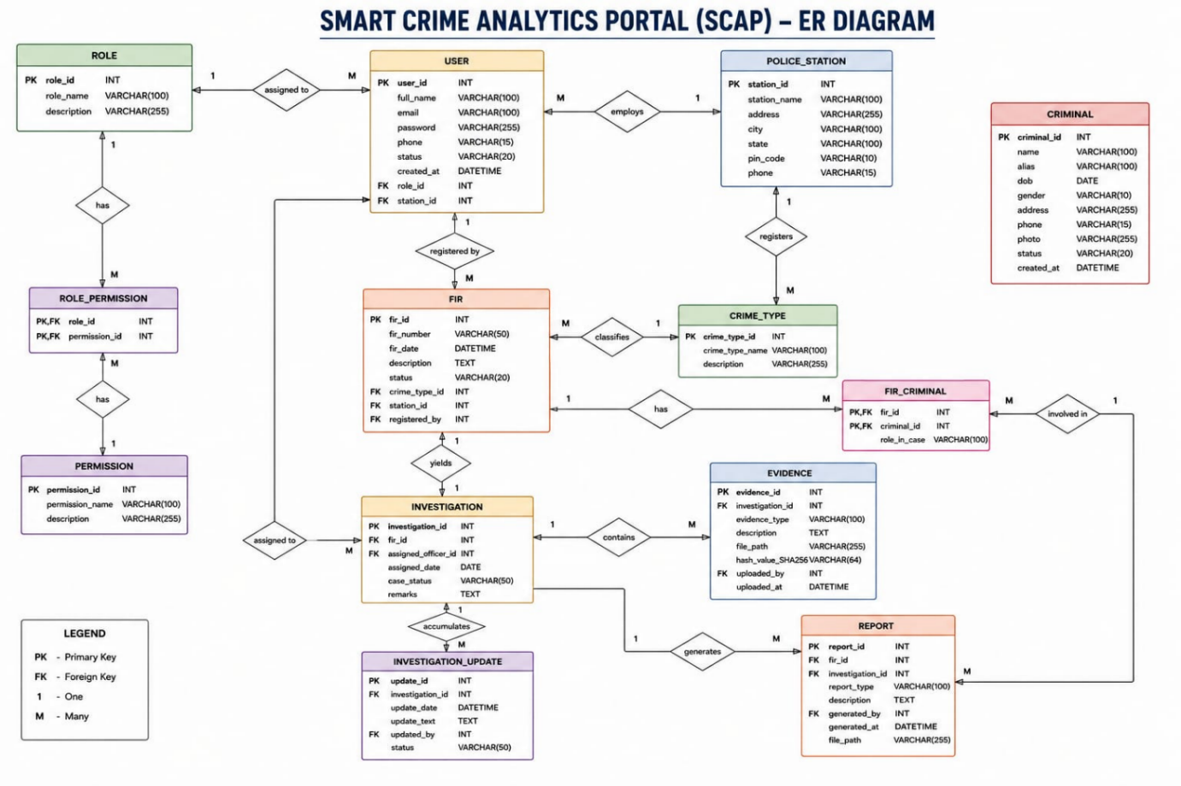

3.3 Data Flow Diagram
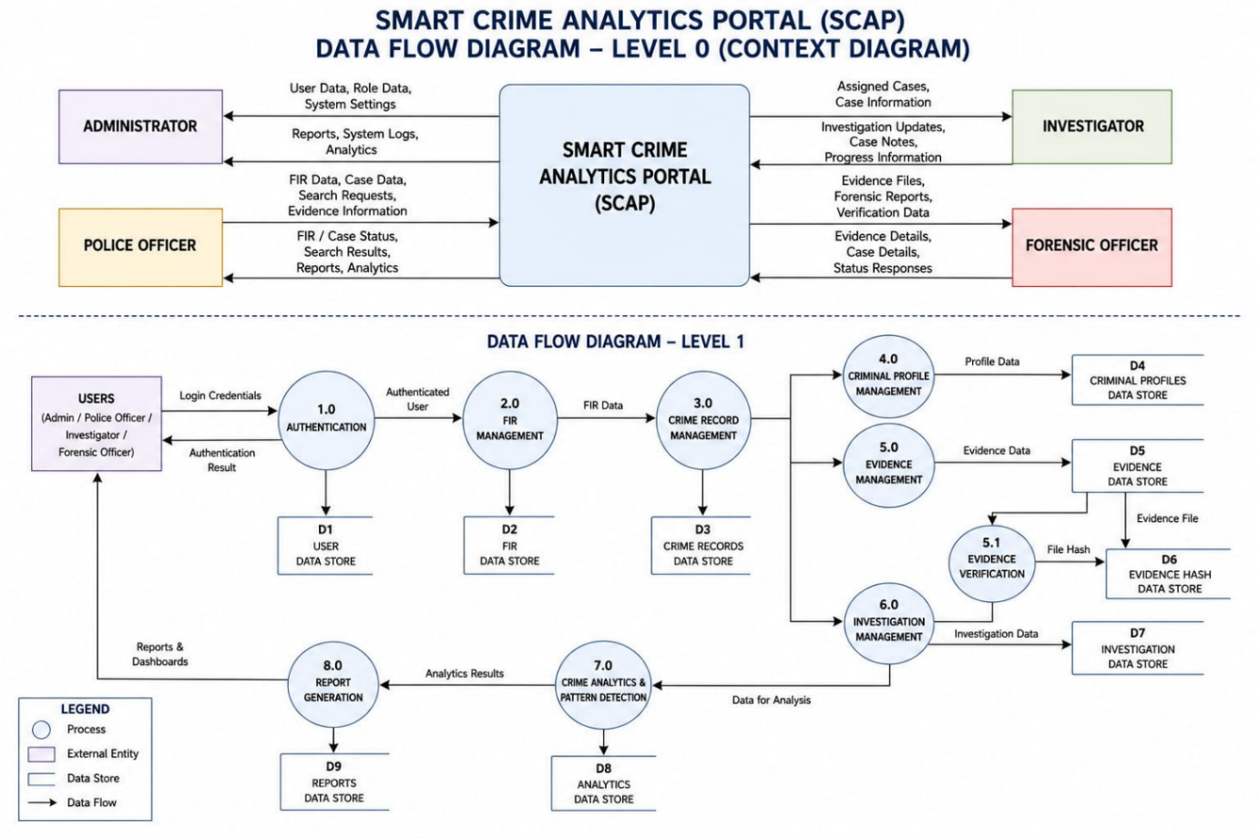

3.4 Sequence Diagram
